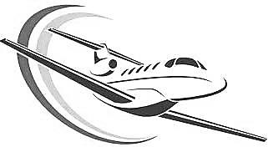
450/1
AVIATION TECHNOLOGY
FORM 1
JUNE 2022
END OF TERM 1 EXAM

TIME: 2 hours

NAME……………………………………………… ADM NO…………….

CANDIDATE’S SIGN:…...……… CLASS: …………. DATE…………..

PIONEER GROUP OF SCHOOLS JOINT EXAM

INSTRUCTIONS TO CANDIDATES
- Answer all questions on the spaces provided.
-Marks for each question are indicated.
-All diagrams must be clearly drawn with a pencil and labeled with a pen.
-Ensure you have written your name and admission number.
-Ensure you have drawing instruments.

Question | 1 | 2 | 3 | 4 | 5 | 6 | 7 | 8 | 9 | Total
Marks |  |  |  |  |  |  |  |  |  | 100

- Draw a well labeled diagram of an aircraft empennage section. (10mrks)

- State any four roles played by each of the following aviation personnel: (12mrks)
- Flight engineer

- Ground controller

- Navigator

- With a labeled diagram, show the stages of a successful flight. (5mrks)

- List any five roles of aviation to the Kenyan economy. (5mrks)

- State two functions of each of the following aircraft parts. (6mrks)
- Fuselage

- Undercarriages

- Power plant
- State the four forces that act on an aircraft in flight. (4mrks)

- State five entries made by the flight engineer in the technical log book. (5mrks)

- State five qualifications for one to become a pilot. (5mrks)

- Identify the following pilot licenses by writing them in full. (8mrks)
- SPL

- PPL

- CPL

- ATPL

